Introduction
Purpose
The purpose of this Software Requirements Specification (SRS) is to define the functional and non‑functional requirements for the Find A Spot Smart Parking Platform. This document provides a detailed description of system behavior, constraints, assumptions, and interactions to ensure all stakeholders share a unified understanding of the project.
Intended Audience
- Project Manager
- Product Owner
- Business Analyst
- Developers
- QA/Testers
- UX Designers
- DevOps Engineers
- City Planners
- Parking Operations SMEs

Scope
Find A Spot is a mobile app designed to provide real‑time parking availability, reservations, navigation, and payment processing. The system aims to reduce congestion, improve user confidence, and modernize outdated parking infrastructure.

Definitions & Acronyms
SRS – Software Requirements Specification
NFR – Non‑Functional Requirement
FR – Functional Requirement
SME – Subject Matter Expert\
GPS – Global Positioning System

Overall Description
System Perspective
- The system integrates mobile app functionality, garage sensors, navigation APIs, and payment gateways to deliver real‑time parking management.
User Classes & Characteristics
- Drivers: Primary users who search, reserve, and pay for parking.
- Garage Operators: Manage garage information, availability, and sensor data.
- Administrators: Oversee system performance, reporting, and issue resolution.

Operating Environment
iOS and Android mobile devices
Cloud‑based backend services
Garage sensors and IoT devices
Third‑party navigation and payment APIs

Constraints
Requires stable GPS signal
Dependent on sensor hardware accuracy
Requires city approval for garage integration
Must comply with data privacy and security regulations

Assumptions & Dependencies
Users have smartphones with internet access
Garages support digital reservations
Payment processors remain available
Sensor hardware is installed and maintained

System Features

FR‑1: Account Creation
The system shall allow users to register for a driver account.
FR‑2: User Authentication
The system shall authenticate users during login and logout.
FR‑3: Search for Parking
The system shall allow users to search for available parking spots or garages.
FR‑4: Real‑Time Availability
The system shall display current parking availability using sensor data.
FR‑5: Reserve Parking Spot
The system should allow users to reserve a parking spot in advance.
FR‑6: Cancel Reservation
The system shall allow users to cancel a reservation before being charged.
FR‑7: Payment Processing
The system should allow users to pay for parking before or upon arrival.
FR‑8: Navigation
The system shall provide turn‑by‑turn navigation to the selected parking spot.
FR‑9: Notifications
The system should send reservation updates and reminders to users.
FR‑10: Garage Information
The system should display detailed garage information, including pricing and restrictions.
FR‑11: Reservation History
The system will allow users to view past reservations.
FR‑12: Payment History
The system shall allow users to view and manage past payments.
FR‑13: Extend Parking Time
The system allows users to extend their parking session.
FR‑14: Reporting
The system shall generate analytics and usage reports.
FR‑15: Sensor Updates
The system should update availability based on real‑time sensor data.

Non‑Functional Requirements (NFRs)
NFR‑1: Performance
The system should update parking availability every 5 seconds.
NFR‑2: Security
The system shall encrypt all user data in transit and at rest.
NFR‑3: Usability
The system shall allow users to reserve a parking spot in under three steps.
NFR‑4: Reliability
The system shall maintain 99.5% uptime.
NFR‑5: Scalability
The system shall support up to 100,000 concurrent users.
NFR‑6: Compatibility
The system will operate on current iOS and Android versions.

Existing software landscape
The top 3 parking applications that will be competition are ParkMobile, SpotHero, and ParkWhiz. (this is based on a quick google search which is assumed to be what most users will do) While each app is okay in their on right, they have a lot of opportunities that I feel our application will outshine them.
Our app “Find A Spot” will have real time updates, fast pay, navigation, and overall mobile experience to make parking easy and stress free.
Vision and scope
We took this project on to improve all the congestion and the overall confusion that one feels when they must find a parking spot. Research shows that most people aren’t that confident when it comes to finding available parking when in need, and the current structure feels out of date and lacks real technology. We wish to design and develop a full ecosystem that will be fully integrated with navigation and real-time parking management.
Our company has unlimited resources and is backed by certain government sectors to find a working solution to the major issues concerning parking.
Our overview is to build an application that will allow you to see various available locations to park. From there you will be able to reserve and pay for that spot in advance. With the app you will have access to live availability, navigation, parking requirements, and payment options. We want to make parking less stressful and alleviate traffic.

Use case
- Create Driver Account- Users register for an account
- Login- Users get access
- Search for Parking- Users search for available parking spots or garages
- View Real-Time Availability- Users see current available parking spots
- Reserve Parking Spot- Users can pick a spot in advance
- Cancel Reservation- Users can cancel before being charged
- Pay for Parking- Users can pay before or upon arrival
- Navigate to Garage- Turn by turn navigation to chosen parking spot
- Updates Availability- App shows real time availability
- Generate Reports- App shows analytics
- Send Notifications- App sends updates on reservation
- Upload Garage Information- Users can see information on the spot or the garage
- View Reservation History- Users can see past places that they have parked
- View Payment History- Users can manage payments
- Extend Parking Time- Users can extend parking if need be

User stories
Driver
1. As a driver, I want to receive alerts when my parking time is about to expire so that I can extend it and avoid fees.
2. As a driver, I want to filter parking options by price, distance, and garage type so that I can choose the best spot for my needs.
Admin
3. As an admin, I want to update garage pricing, rules, and restrictions so that drivers always see accurate information.
4. As an admin, I want to deactivate or flag malfunctioning sensors so that inaccurate availability does not appear in the app.
City Planner
5. As a city planner, I want to view aggregated parking trends so that I can make informed decisions about traffic and infrastructure.
6. As a city planner, I want to approve new garage integrations so that only verified locations appear in the app.
System
7. As the system, I want to automatically sync sensor data every few seconds so that parking availability remains accurate.
8. As the system, I want to retry failed sensor updates so that temporary connectivity issues do not break availability.

WBS

- Build the app
  - Round table
    - Meet with the full team
    - Go over design of the app
    - Go over all the parking garages and spaces
  - Account Management
    - Registration and login
    - Authentication
    - Create profile
    - Set up payment portal
  - Map to find parking
    - Use location
    - Select destination
    - Suggest nearby parking
    - Show availability and details
    - Offer filtering
  - Reserve spot
    - Select spot
    - Pick a time
    - Confirm spot
  - Make a payment
    - Pay by card or banking app
    - Generate receipts
    - Confirm payment

Gantt chart

TASK | DURATION | START | END | TIMELINE
Round Table | 2 weeks | September 18, 2026 | October 2, 2026
Account Management | 2 weeks | September 25, 2026 | October 9, 2026
Map to find Parking | 3 weeks | October 12, 2026 | November 2, 2026
Reserve Spot | 2 weeks | October 12, 2026 | October 26, 2026
Make a Payment | 2 weeks | October 12, 2026 | November 2, 2026

Trello

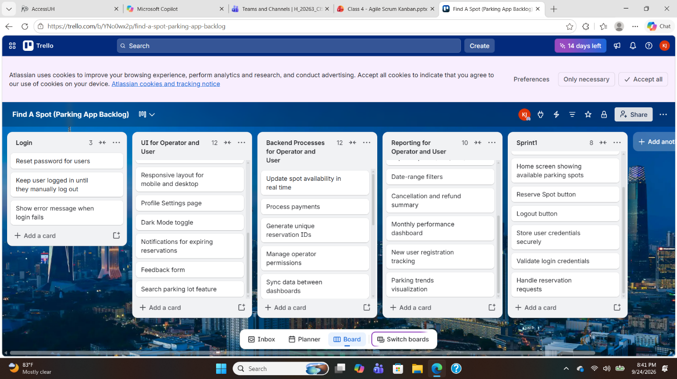
Risk
Technical
- Cybersecurity breach exposing customers information
- Customers experiencing signal loss
- Navigation system not taking customers to their desired location
- Parking sensors not sending out real time information
Schedule
- The total project takes longer than expected
- Testing reveals bigger issues that require more time
- It takes longer to get approval from the city
- Getting all the equipment needed on time to update every parking garage and spot
Financial
- Certain components need to be updated or upgraded constantly
- Advertising and marketing may cost more than expected
- May have to hire extra employees on all levels
- Unexpected cost if someone is hurt or vehicle is damaged
People
- Someone can unknowingly take a reserved space
- People struggling on how you use the app
- Poor communication throughout all levels of the company
- Customers getting frustrated if their spot is taken

Description | Risk | Probability | Mitigation | Owner
Technical | Cybersecurity breach exposing customers information | Medium | Use strong security measures, encryption, secure logins, and regular security testing | IT
Technical | Customers experiencing signal loss | Medium | Improve connectivity support | IT
Technical | Navigation system not taking customers to their desired location | Medium | Constantly test gps services and manage updates | Software Engineer
Technical | Parking sensors not sending out real time information | High | Testing equipment and maintain all sensors | Repair Technician
Financial | Advertising and marketing may cost more than expected | Medium | Track spending and develop a detail marketing strategy | Marketing Manager
Financial | May have to hire extra employees on all levels | High | Plan staffing needs early and stay and stay fully staffed | HR Manager
Financial | Unexpected cost if someone is hurt or vehicle is damaged | Medium | Establish safety procedures, insurance coverage, and a process for handling incidents | Operations Leader
People | Customers getting frustrated if their spot is taken | High | Have customer support and a clear process for resolving reservation conflicts | Customer Service
People | Someone can unknowingly take a reserved space | High | Have security doing real time checks to ensure that everything is done properly | Security
People | People struggling on how you use the app | Medium | Provide videos in the app to help people navigate the app | Customer Service

Meeting
We will do weekly meetings with blanket coverings on everything that is going on. From those meetings we will send out more detailed documents for further explanation.
We can do daily communication from the project managers and the direct team.
We can meet with city planners bi-weekly to make sure no surprises come up
Roles
Project Manager – Plans, tracks, manages stakeholders
Product Owner – Defines product vision, prioritizes backlog
Business Analyst – Requirements, documentation, user stories
Developers – Writes code, integrates APIs, builds features
QA / Tester – Validates behavior, writes test cases
UX Designer – User flows, wireframes, mobile experience
DevOps Engineer – CI/CD, deployment automation
SME – Parking operations expertise

Role |  |  |  | Name |  | FTE % | Hours | Rate | Cost
Project Manager |  |  |  | Kevin Jones |  | 20% | 80 | $45/hr | $3,600
Product Owner |  |  |  | Jordan Mitchell |  | 10% | 40 | $50/hr | $2,000
Business Analyst |  |  |  | Sam Parker |  | 15% | 60 | $40/hr | $2,400
Developer 1 |  |  |  | Bob Anderson |  | 50% | 200 | $45/hr | $9,000
Developer 2 |  |  |  | Carol Thompson |  | 50% | 200 | $45/hr | $9,000
QA Tester |  |  |  | Dan Roberts |  | 25% | 100 | $30/hr | $3,000
UX Designer |  |  |  | Mia Collins |  | 15% | 60 | $40/hr | $2,400
DevOps Engineer |  |  |  | Leo Martinez |  | 20% | 80 | $50/hr | $4,000
SME (Parking Ops) |  |  |  | Victor Ramirez |  | 10% | 40 | $55/hr | $2,200
TOTAL |  |  |  |  |  |  | 860 |  | $37,600
Month | Labor | Infra | Licenses |  | APIs | Contingency | Total
Month 1 | $7,000 | $300 | $500 |  | $200 | $800 | $8,800
Month 2 | $7,000 | $300 | $0 |  | $250 | $800 | $8,350
Month 3 | $6,500 | $300 | $0 |  | $300 | $800 | $7,900
Month 4 | $6,000 | $300 | $0 |  | $350 | $700 | $7,350
Month 5 | $5,800 | $300 | $0 |  | $400 | $700 | $7,200
Month 6 | $5,300 | $300 | $0 |  | $500 | $700 | $6,800
Total | $37,600 | $1,800 | $500 |  | $2,000 | $4,500 | $46,400

Task | PM | PO | BA | Dev | QA | UX | DevOps | SME | Sec
Requirements | A | C | R | C | I | C | I | C | C
Design | A | C | C | C | I | R | I | C | C
Implementation | A | I | C | R | C | C | C | I | C
Testing | I | C | C | C | A/R | I | C | C | C
Deployment | A | I | I | C | C | I | R | I | C
Security Setup | I | I | C | R | C | I | C | C | A
Parking Availability Validation | I | C | C | C | C | I | I | A/R | I
Project Planning and Tracking | A/R | C | C | I | I | I | I | I | I
User Acceptance Testing | A | R | R | C | C | C | I | C | I
Launch and Handover | A | C | C | R | C | I | R | C | C

